# **Practical Application: Basic Graphic Design Elements Infographic**

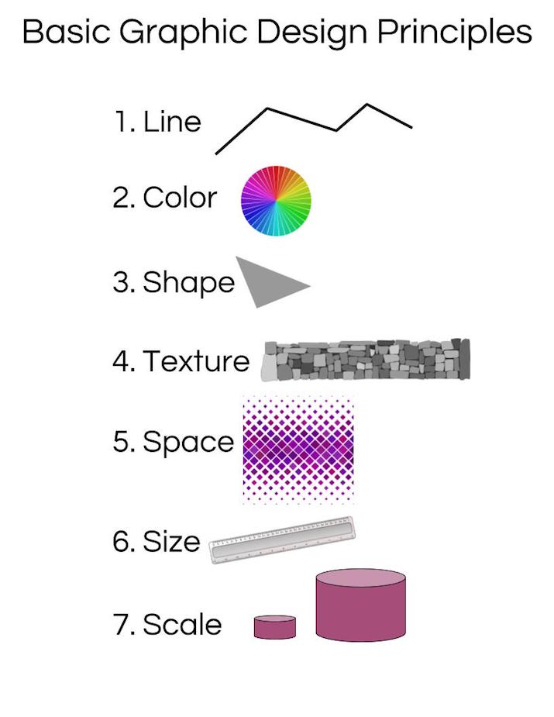

## **Basic Graphic Design Principles**

Although you might not be able to name the basic graphic design principles off the top of your head right now, most of us are immersed in graphic design every day. Graphic design is used to design all of the logos, advertisements, marking, and products that we use on a daily basis. Although there is a wide range of designs that can be created, all graphic designers use seven basic principles, as described in the lesson [Basic Graphic Design Elements Overview](https://study.com/academy/lesson/basic-graphic-design-elements-overview.html):

1. Line
2. Color
3. Shape
4. Texture
5. Space
6. Size
7. Scale

These elements can be represented using an infographic. Infographics help us visually represent information, giving our brains a new way to integrate it into our memory. Infographics can also be displayed in our workplace, reminding us of the important elements of our work.

## **Analysis**

The first element of graphic design is the line. Lines can be curved or straight and are often used to separate ideas and space in a piece. The second element is color. Graphic designers are familiar with the color wheel and complementary colors that go well together. Graphic designers also use shapes. These may be geometric shapes as pictured here, or abstract shapes to communicate an idea.

Texture is often an image of a background, such as brick or stone. These can be incorporated as background in a design or as a focal subject. The use of space, both positive and negative space, is also important in a design. The elements and where they are placed communicates a message to the viewer. Negative space, or the white space in a design, can be just as important as the objects themselves, as depicted in the infographic.

Lastly, size and scale are important aspects of design. Size is how big certain elements are, whereas scale is how big objects are relative to each other. Scale can be used to emphasize the importance of certain messages in a design.